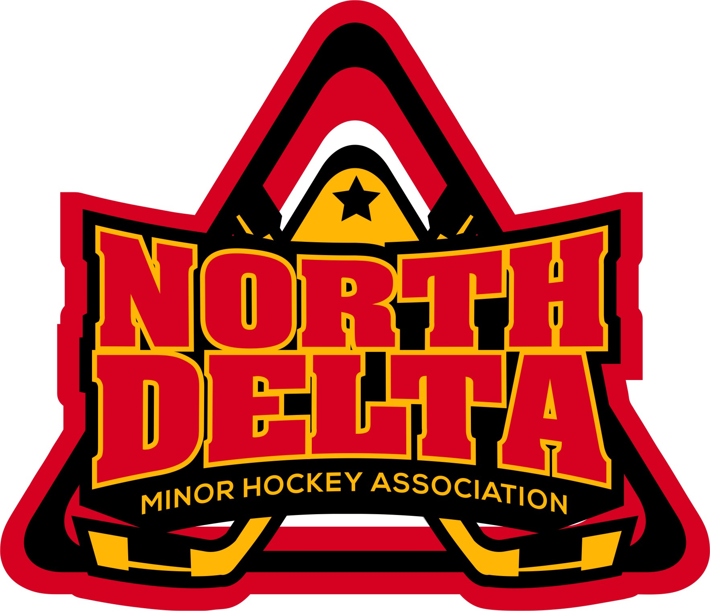 | North Delta Minor Hockey Association  102 – 7815 – 112th Street  Delta, BC V4C 4V9

Request for Refund
- Players withdrawing from ND Hockey after September 1st, will be subject to a reduction in their refund of registration at the rate of $60.00 per month or any portion thereof up to December 1st. No refund shall be made after December 1st.
- Rep Try –out and Late fee are non-refundable.
- The refund amount will be calculated on a pro-rated basis from the date received.
- No refunds will be processed until after October 15th.
- It is the responsibility of the parent or player to apply in writing for any refund. If a player is expelled or suspended, no refund shall be granted.
- Submit request to Attention Registrar
ND Hockey Office
102 – 7815 – 112th Street
Delta, BC V4C 4V9

Personal Information
PLEASE PRINT

Name of Player:
Division: Hockey 1-4  Atom  PeeWee  Bantam  Midget  Juvenile 
Team:
Name of Parent:
Address:
City:
Postal Code:
Telephone:
Date of last skate:
Coaches Name:
Reason for Withdrawal: ________________________________________________________________________________________________________________________________________________________________________________________________________________________________________________________________________

________________________
Signature Date

