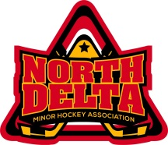 North Delta Minor Hockey Association
Organizational Structure & Communication
Past - President
President

Midget/Juv. C Teams
Midget/Juv Div. Mgr.
Board
Executive Committee &
Appointed Members:
Coach Coordinator
Division Managers
Gaming
Promotions
IT
Rules Committee
Goalie Development
Sponsorship
Suppliers of Services Contracted – report to Director responsible (i.e. Director of Hockey Operations, Goalie Dev., Vendors)
Executive Committee
Elected – 2 year term
President
1st Vice President
2nd Vice President
Treasurer
Ice Scheduler
Equipment Manager
Parent Auxiliary
Referee In Chief
Registrar
Risk Manager
Secretary
Parent Auxiliary Tournament Director

Committees
Finance
Discipline
Appeals
Rules & Regulations
Development
Recreational
Coach Selection
Nomination
Promotions
Ice Negotiation

Bantam C Teams
Atom to Juvenile A1 & A2 Teams.
1st Vice President
2nd Vice President
H1-4 C Teams
H1-4 Coordinators
H 1-4 Div. Mgr.
Bantam Div. Mgr.
Atom Div. Mgr.
Atom C Teams
Pee Wee C Teams
Pee Wee Div. Mgr.

