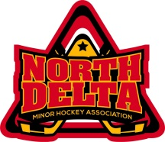 North Delta Minor Hockey Association
Team Structure and Communication
President

Teams Positions
Teams Positions
Director of Hockey Operations

Development Committee
Goalie Development
Coach Coordinator

Atom to Juvenile A1 & A2 Team
Managers
Board
Treasurer
Ice Scheduler
Equipment Manager
Parent Auxiliary
Referee In Chief
Registrar
Risk Manager
Secretary
Parent Auxiliary Tournament Director
IT
Promotions

C Teams Parents
C Teams Parents
H14 to Midget
C Team
Coaches
Atom to Juvenile A1 & A2 Team
Coaches
H14 to Midget
C Team
Managers
Division Managers
1st Vice President
2nd Vice President

